INTERFACING OF RELAY AND BULB WITH 8051 USING PROTEUS

PROGRAM:
ORG 0000H
UP: SETB P2.0
ACALL DELAY
CLR P2.0
ACALL DELAY
SJMP UP
DELAY: MOV R4,#18
H1: MOV R3,#255
H2: DJNZ R3,H2
DJNZ R4,H1
RET
END

STEPS:

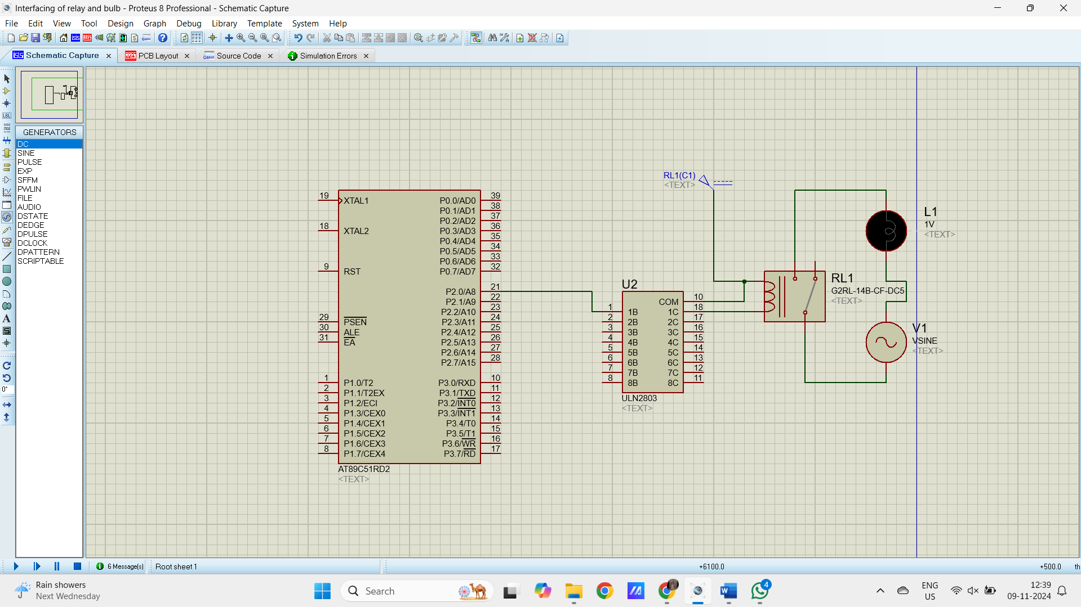

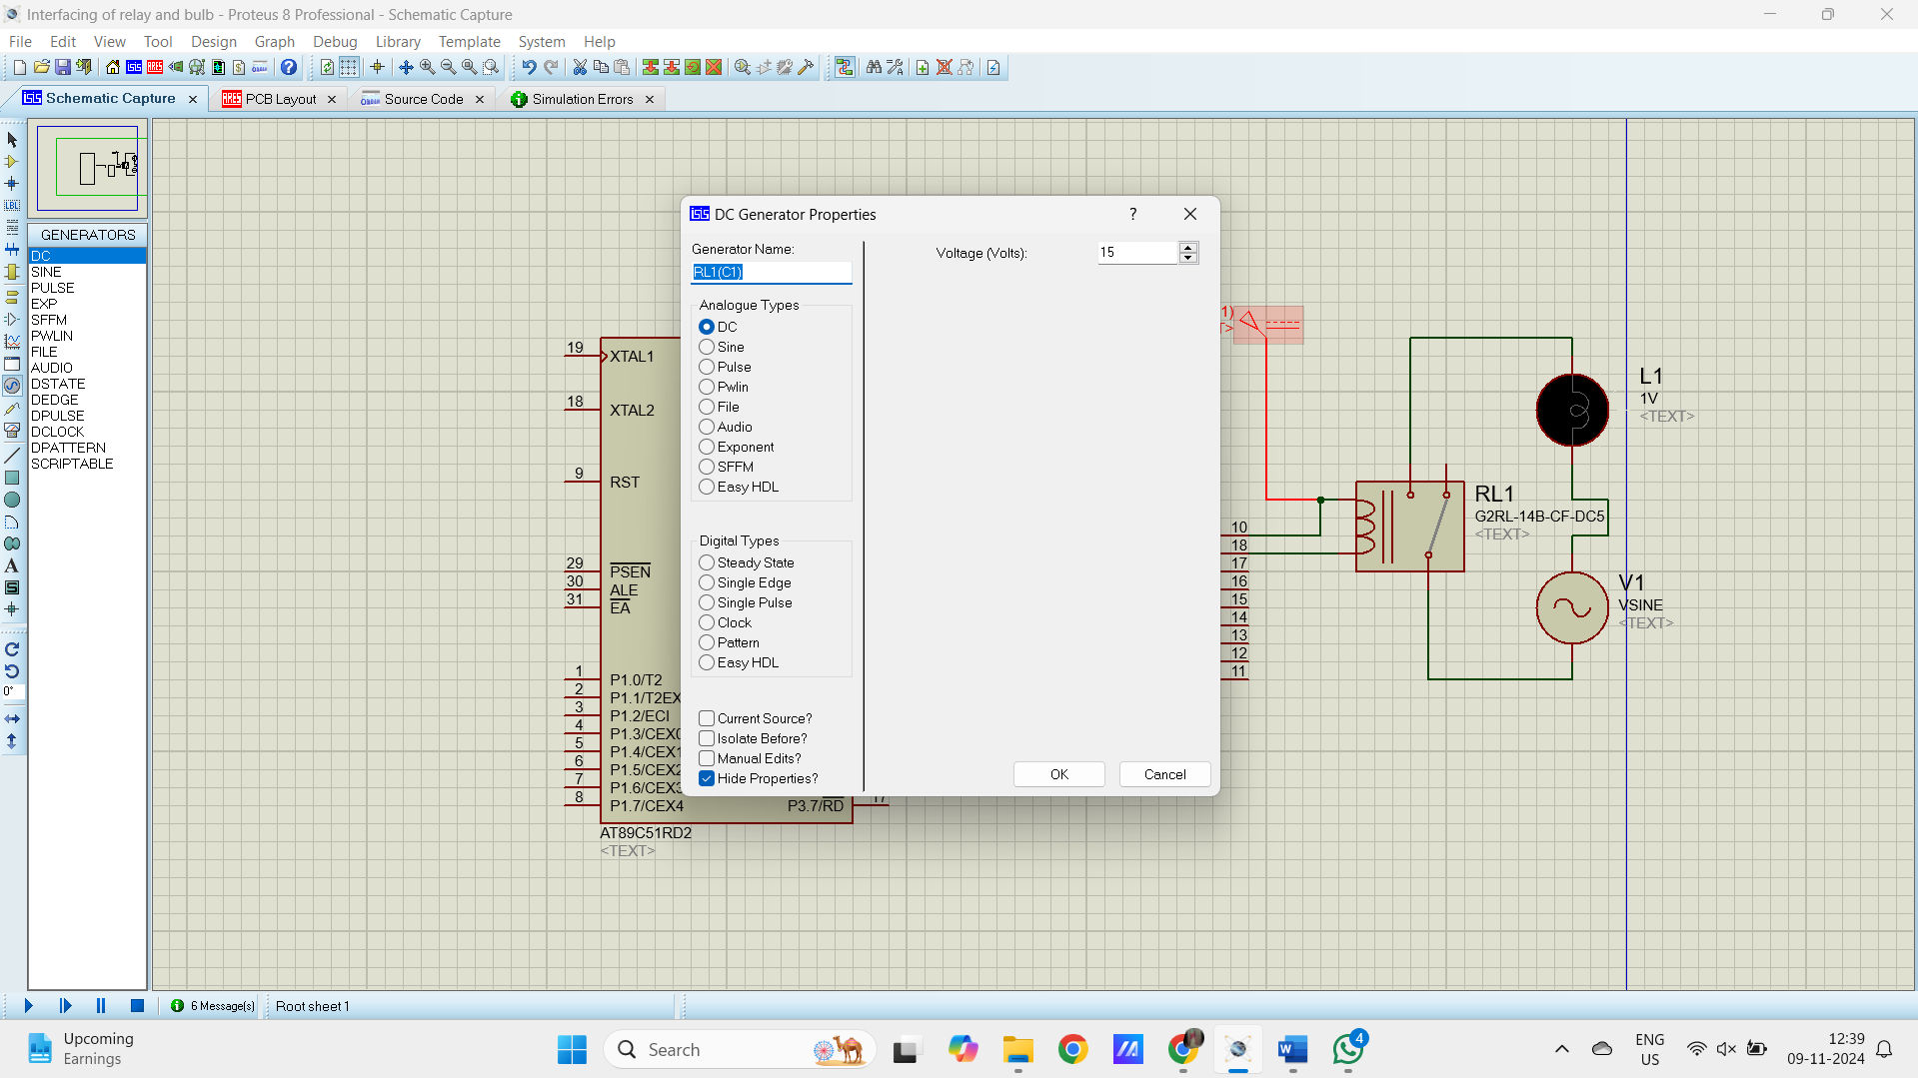

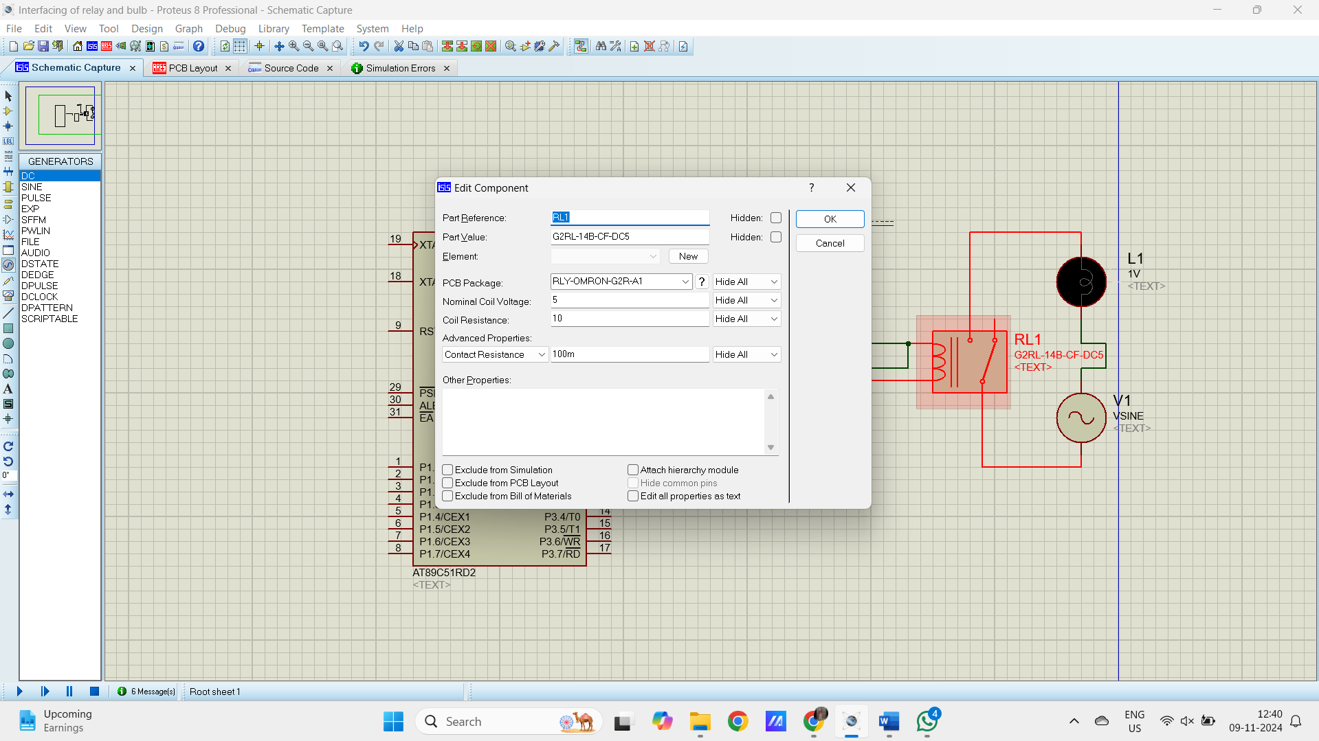

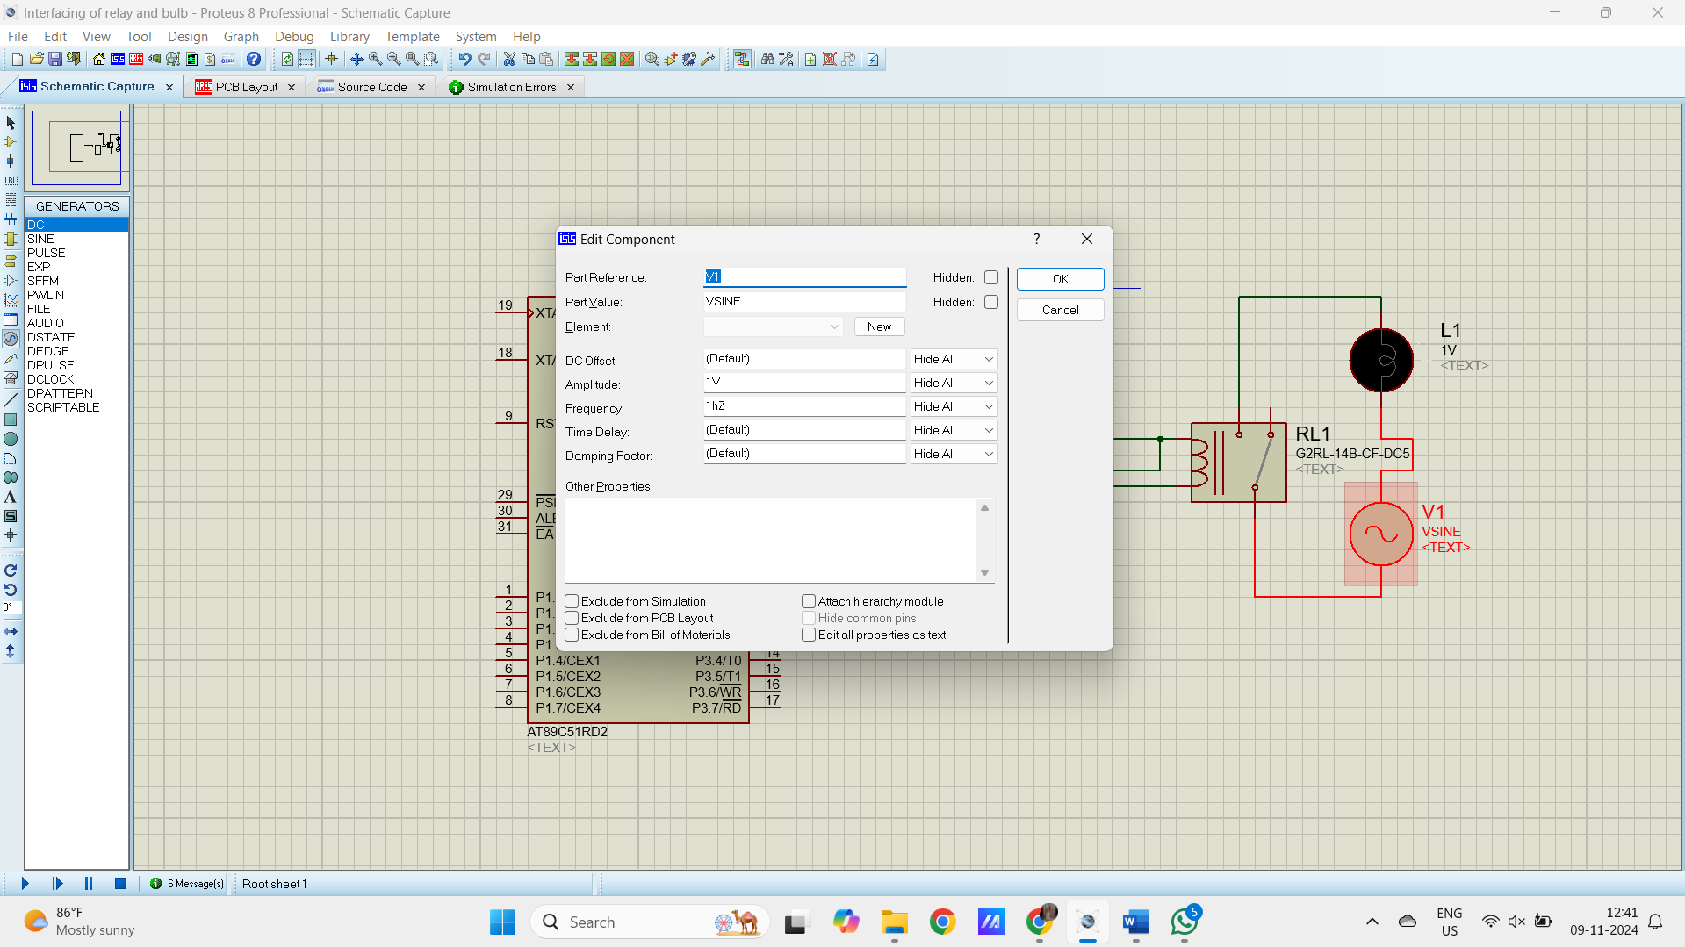

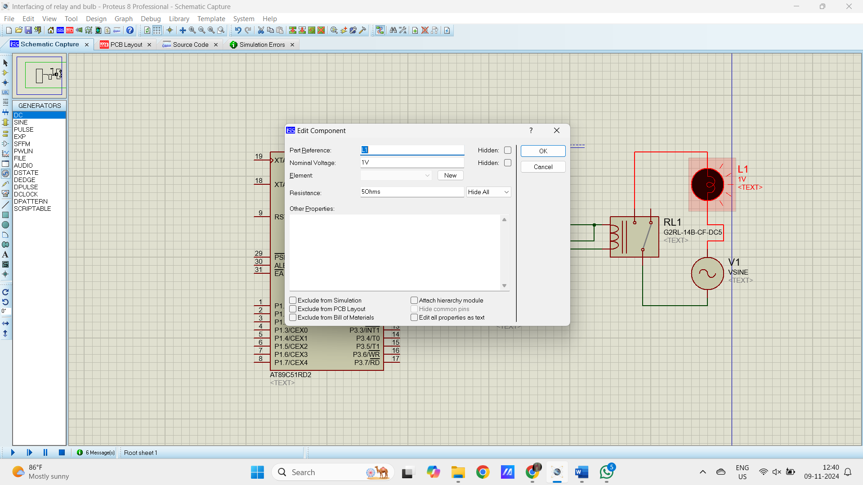

OUTPUT:

